C PROGRAMMING ASSIGNMENT
Scientific Calculator
Using Switch Statement
Documentation Report
Submitted by | Vishal Prajapati
Roll Number | FDAI044-A
Subject | Programming with C
Faculty In-charge | Dr. Kishor Mahajan
Class | FY-BSC AI
Date | 25 August 2026

Contents
1. Assignment Overview
2. Problem Statement and Objectives
3. Input and Output Specification
4. Algorithm
5. Program Logic and Flowchart
6. Implementation Details
7. Source Code
8. Test Cases and Verified Output
9. Conclusion
10. References

1. Assignment Overview
This project implements a menu-driven scientific calculator using a switch statement. It performs addition, subtraction, multiplication, division, modulus, power, and percentage calculations. The program is designed as a console application so that the relationship between a numbered menu and fixed operation choices remains visible and easy to test.
Item | Description
Assignment | Assignment 1 — Scientific Calculator
Application type | Menu-driven console application
Primary C concepts | switch statement, arithmetic operators, double and int data types, pow(), input validation, do-while repetition
Execution model | Interactive input, validation, operation, and repeated menu processing
Compiler command | gcc source_file.c -lm

2. Problem Statement and Objectives
- Use a switch statement to select one operation from a numbered menu.
- Perform arithmetic operations with suitable numeric data types.
- Prevent division by zero and modulus by zero.
- Reject choices outside the valid menu range and clear invalid menu input.
- Allow multiple calculations until the user selects Exit.

3. Input and Output Specification
Menu option | Input required | Expected output
1 — Addition | Two real numbers | Their sum formatted to two decimals
2 — Subtraction | Two real numbers | First number minus second number
3 — Multiplication | Two real numbers | Their product formatted to two decimals
4 — Division | Dividend and divisor | Quotient, unless divisor is zero
5 — Modulus | Two integers | Integer remainder, unless divisor is zero
6 — Power | Base and exponent | Base raised to exponent
7 — Percentage | Value and percentage | Requested percentage of the value
8 — Exit | No additional input | Termination message

4. Algorithm
- Display the calculator menu.
- Read the user’s menu choice. If the choice is not an integer, clear the invalid input and display an error message.
- Use switch(choice) to route control to the selected operation.
- For division and modulus, validate the second operand before evaluating the operator.
- For modulus, read integer operands because the C modulus operator is used with integers.
- Display the result or the relevant error message.
- Repeat the menu until the user selects option 8, Exit.

5. Program Logic and Flowchart
The program begins with a do-while loop that displays the menu and reads a choice. The switch statement maps each fixed integer choice to one operation. The division and modulus branches perform zero-divisor checks before calculation. After the result or error message is displayed, control returns to the menu. Selecting option 8 displays the exit message and terminates the loop.
Flowchart symbol key
Rounded rectangle = Start/End; parallelogram = Input/Output; rectangle = Processing; diamond = Decision; circle = Connector.

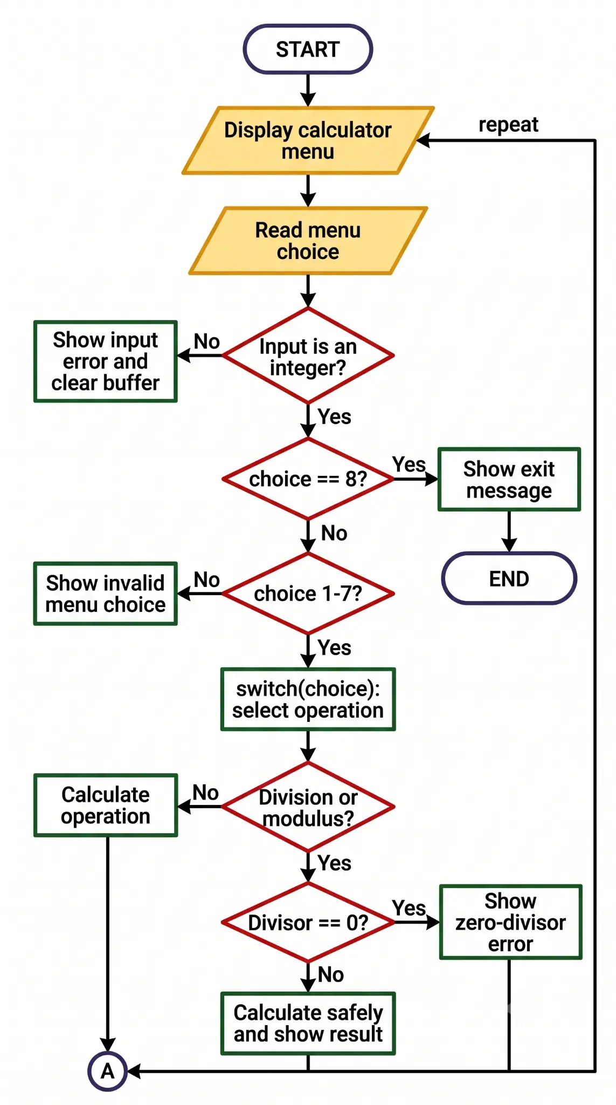
Figure 1. Scientific calculator flowchart using standard geometric symbols and directed arrows.

6. Implementation Details
The variables a, b, and result use the double type so that division, power, and percentage calculations can produce fractional results. The modulus operation uses intA and intB because the % operator is intended for integer operands in this program. The pow() function from math.h performs power calculation; therefore, the program is compiled with the math library using gcc scientific_calculator.c -lm.
Why switch is suitable here
The program compares one menu variable with several fixed integer constants. Each case corresponds directly to a numbered menu operation, making the structure easier to read and maintain than a long if-else-if chain. If the conditions involved ranges or complex logical expressions, if-else would be more suitable.

7. Source Code
1 #include <stdio.h>
2 #include <math.h>
3
4 int main(void) {
5 int choice;
6 double a, b, result;
7 int intA, intB;
8
9 do {
10 printf("\n===== Scientific Calculator =====\n");
11 printf("1. Addition\n");
12 printf("2. Subtraction\n");
13 printf("3. Multiplication\n");
14 printf("4. Division\n");
15 printf("5. Modulus\n");
16 printf("6. Power\n");
17 printf("7. Percentage\n");
18 printf("8. Exit\n");
19 printf("Enter your choice: ");
20
21 if (scanf("%d", &choice) != 1) {
22 printf("Invalid input. Please enter a number from 1 to 8.\n");
23 while (getchar() != '\n') {
24 /* Clear invalid input from the keyboard buffer. */
25 }
26 continue;
27 }
28
29 switch (choice) {
30 case 1:
31 printf("Enter two numbers: ");
32 scanf("%lf %lf", &a, &b);
33 printf("Result = %.2f\n", a + b);
34 break;
35
36 case 2:
37 printf("Enter two numbers: ");
38 scanf("%lf %lf", &a, &b);
39 printf("Result = %.2f\n", a - b);
40 break;
41
42 case 3:
43 printf("Enter two numbers: ");
44 scanf("%lf %lf", &a, &b);
45 printf("Result = %.2f\n", a * b);
46 break;
47
48 case 4:
49 printf("Enter dividend and divisor: ");
50 scanf("%lf %lf", &a, &b);
51 if (b == 0) {
52 printf("Error: Division by zero is not allowed.\n");
53 } else {
54 printf("Result = %.2f\n", a / b);
55 }
56 break;
57
58 case 5:
59 printf("Enter two integers: ");
60 if (scanf("%d %d", &intA, &intB) != 2) {
61 printf("Invalid input. Modulus requires two integers.\n");
62 while (getchar() != '\n') {
63 /* Clear invalid input from the keyboard buffer. */
64 }
65 } else if (intB == 0) {
66 printf("Error: Modulus by zero is not allowed.\n");
67 } else {
68 printf("Result = %d\n", intA % intB);
69 }
70 break;
71
72 case 6:
73 printf("Enter base and exponent: ");
74 scanf("%lf %lf", &a, &b);
75 result = pow(a, b);
76 printf("Result = %.2f\n", result);
77 break;
78
79 case 7:
80 printf("Enter value and percentage: ");
81 scanf("%lf %lf", &a, &b);
82 result = (a * b) / 100.0;
83 printf("%.2f%% of %.2f = %.2f\n", b, a, result);
84 break;
85
86 case 8:
87 printf("Exiting calculator. Goodbye!\n");
88 break;
89
90 default:
91 printf("Invalid menu choice. Please choose a number from 1 to 8.\n");
92 }
93 } while (choice != 8);
94
95 return 0;
96 }

8. Test Cases and Verified Output
The following tests were executed after compilation with GCC. They cover normal operations, safety validation, invalid menu handling, and controlled termination.
Test | Input sequence | Observed / expected output | Purpose
1 | Choice 1; 12 and 8 | Result = 20.00 | Addition
2 | Choice 4; 10 and 0 | Division-by-zero error | Safety validation
3 | Choice 5; 10 and 3 | Result = 1 | Integer modulus
4 | Choice 6; 2 and 3 | Result = 8.00 | Power calculation
5 | Choice 7; 200 and 15 | 15.00% of 200.00 = 30.00 | Percentage calculation
6 | Choice 9 | Invalid menu choice | Default case

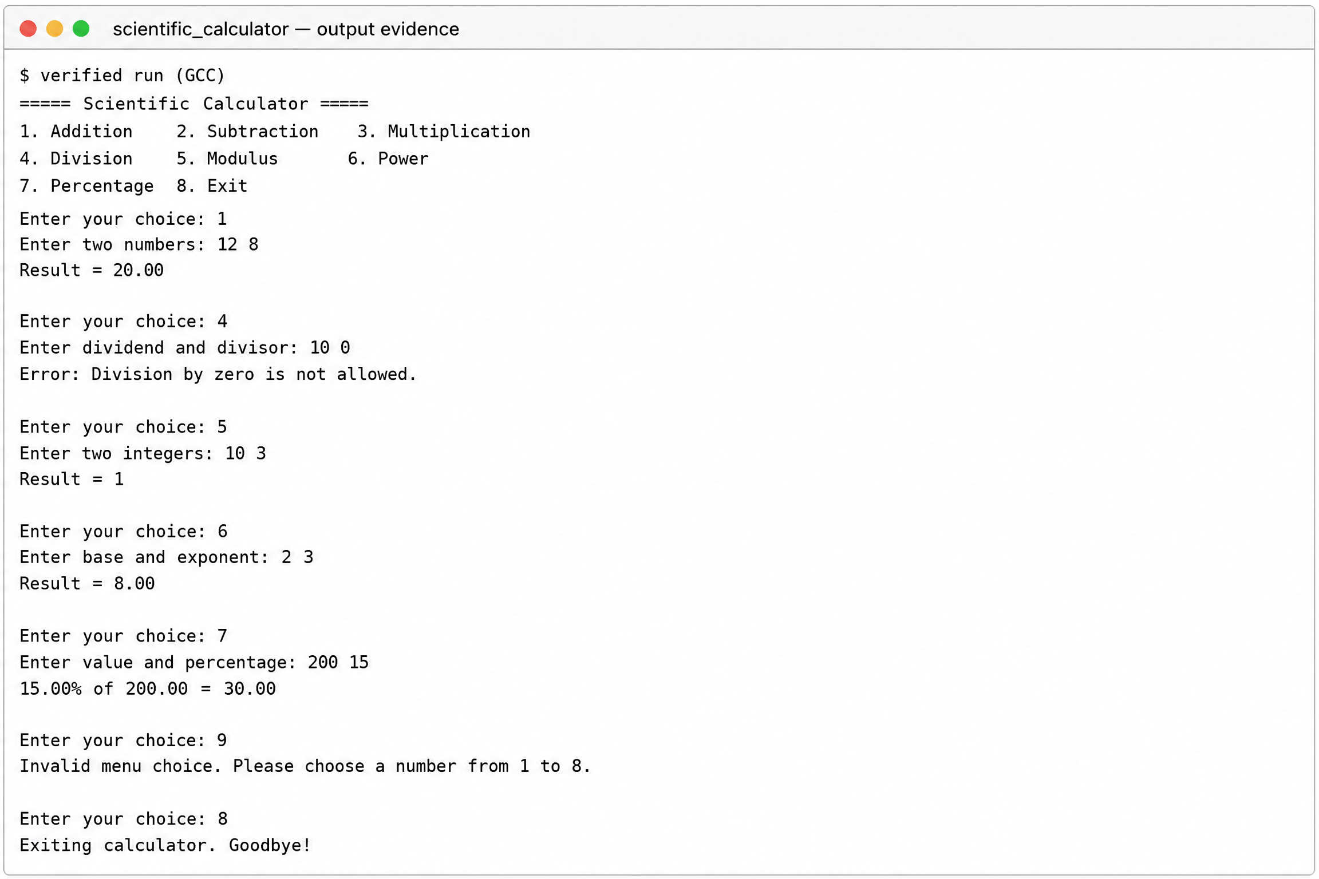
Figure 2. Verified console output showing calculator operations and validation responses.

9. Conclusion
The scientific calculator satisfies the required operations and uses switch as its primary decision structure. It includes checks for invalid menu choices, division by zero, and modulus by zero. The loop supports repeated calculations, while the verified console run confirms the documented outputs.

10. References
[1] ISO C standard library reference, cppreference.com: https://en.cppreference.com/w/c
[2] C switch statement reference, cppreference.com: https://en.cppreference.com/w/c/language/switch
[3] C do-while loop reference, cppreference.com: https://en.cppreference.com/w/c/language/do
[4] C mathematical functions reference, cppreference.com: https://en.cppreference.com/w/c/numeric/math

